**ABOUT THE 50 STARTUPS DATASET**

**ASSIGNMENT -1**

**MANSI MILAN DAVE**

**113219041065**

* Based on R&D spend by profit and states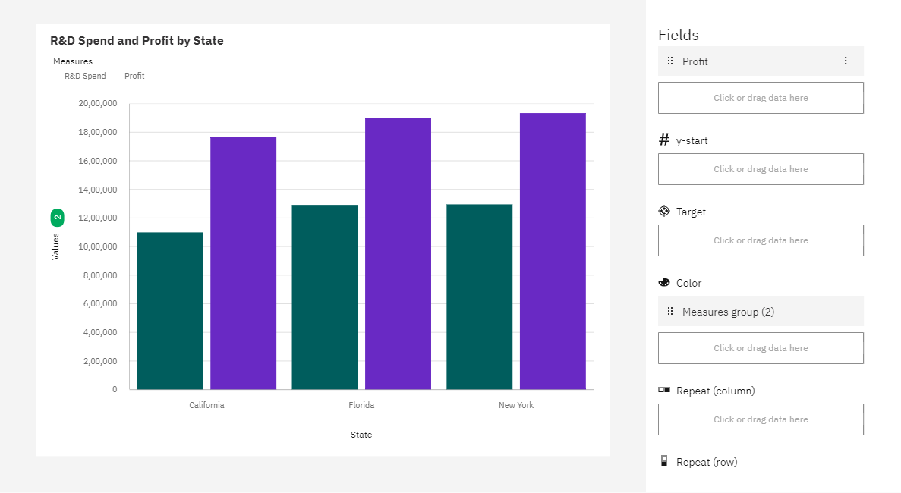
* Based on Marketing and Administration by states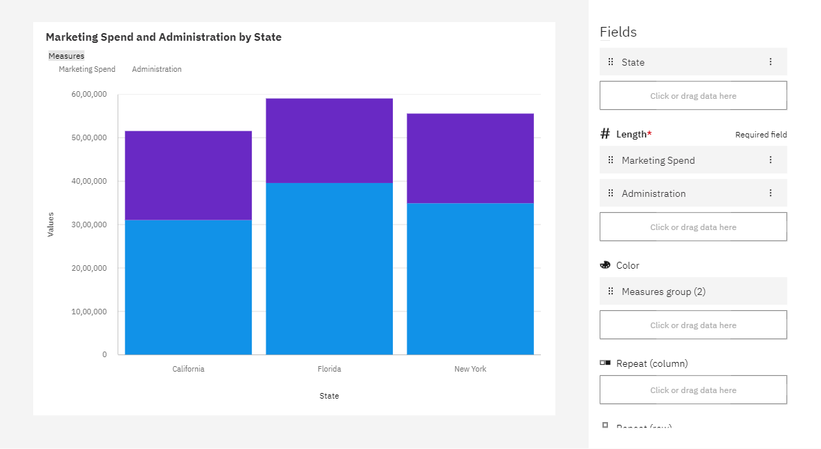
* Based on Administration and profit by states

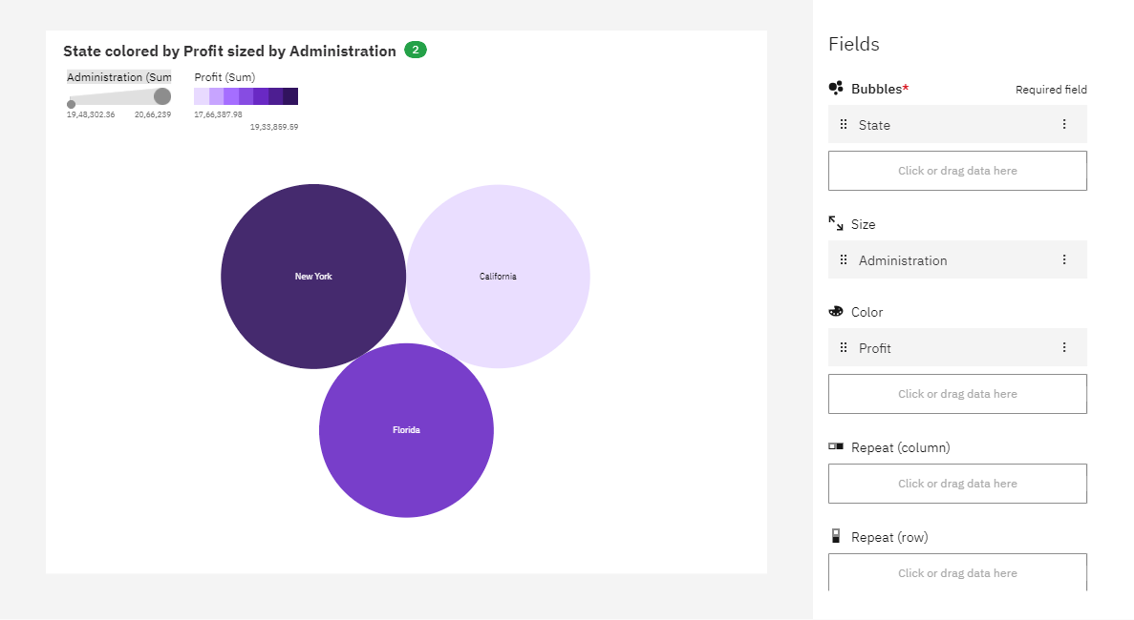

* Based on R&D spend , marketing spend and profit by state

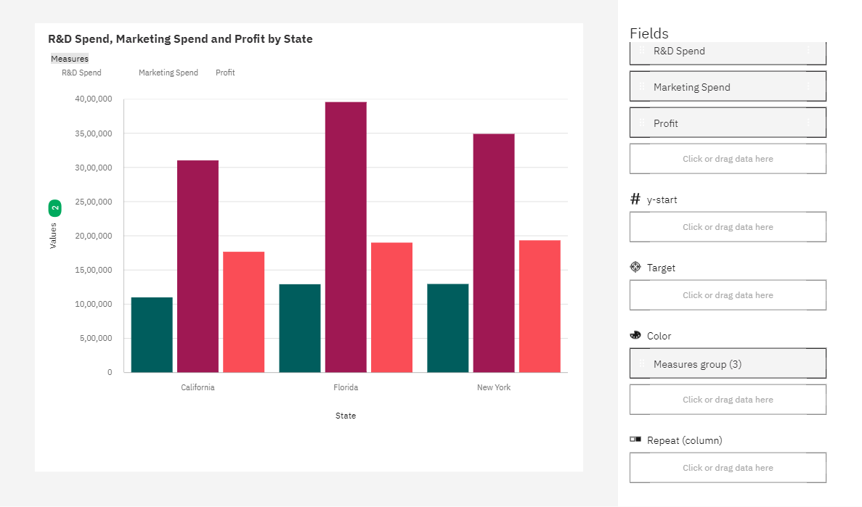

* Based on Marketing spend by state by profit

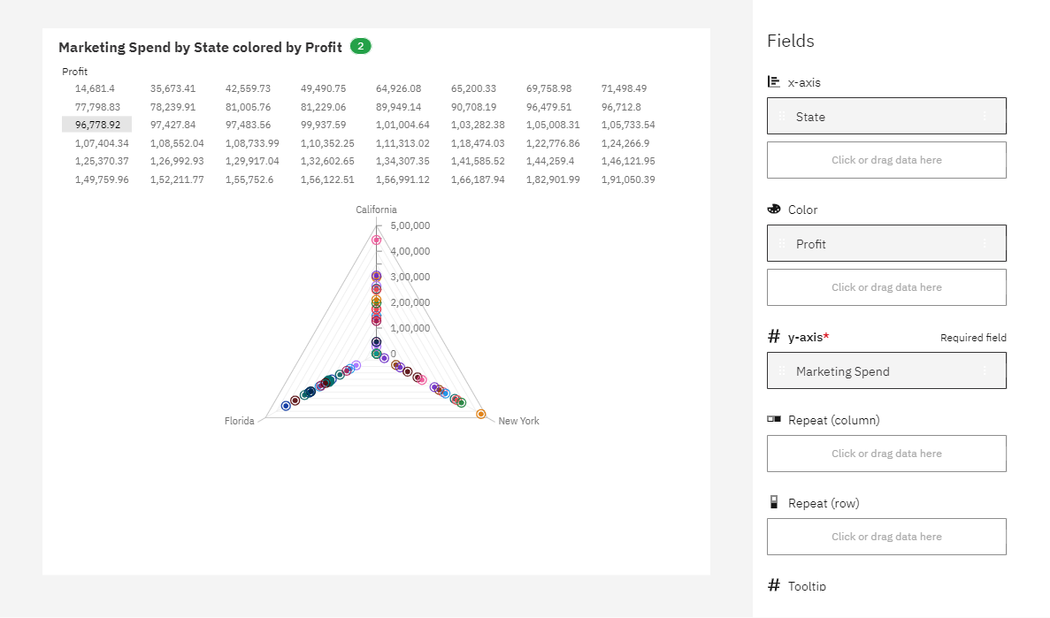

* Based on Marketing spend and profit by state

